**My First Website**

**Day 1:**

1. Press the start button and choose control panel. Choose “Appearances & Personalization

|  |  |
| --- | --- |
|  |  |

1. Click “Folder Options”. In the window that opens, go to the “view” tab. There are several options here. You want to find the checkbox that says “Hide extensions for known file types” and uncheck the box. Click “Apply” then click “OK”. Now you should be able to see the file extension associated with each file.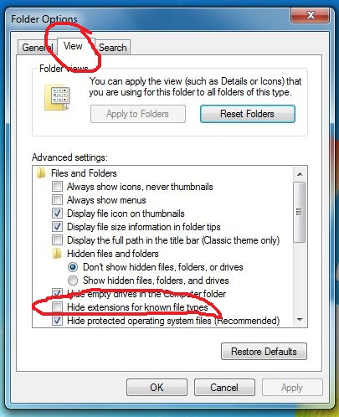
2. We are now going to create a basic web page. Create a new folder on your USB flash drive or desktop named like this: “*First initialLastname_CSP_Website”*. Ex: for me the folder would be called *APittman_CSP_Website*.

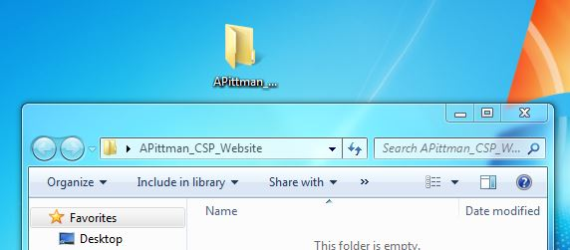

1. Open Notepad++ and paste this HTML code into the editor:

<!doctype html>

<html lang="en">

<!-- The tags below specify the meta (browser data) and page title -->

<head>

<meta charset="utf-8">

<title>Home</title>

</head>

<!-- The tags below are what is displayed on the actual page -->

<body>

<a href="index.html">Home</a>

<a href="portfolio.html">Portfolio</a>

<h1>This is my test Home Page!</h1>

<img src="images/home.jpg" height="250">

</body>

</html>

1. Save the file in the folder you created as “index”. Notice that Notepad++ has automatically given the file the extension “.txt”. This stands for text file, which is a WYSIWYG file type. Right click the file and rename it “index.html”. The computer will warn you, but change the file extension anyway.

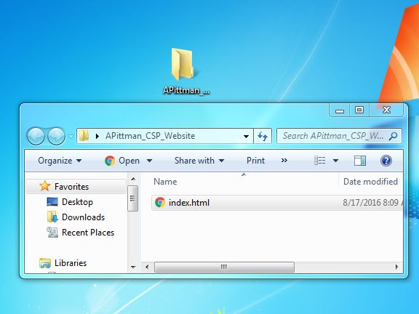

1. Right click the file and choose “Edit with Notepad++” from the options.

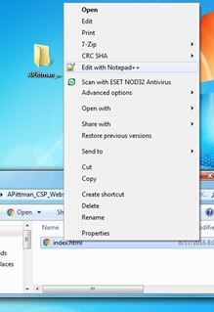

Notice that Notepad++ has color-coded the text to show you what the lines represent. Green is for a comment, tags are blue, values within tags are red, strings are purple, and text is black. Read a basic explanation of tags here: <http://www.w3schools.com/html/html_elements.asp>

1. Close the Notepad++ file. Now double click the index.html file. The file will open in your default web browser. (You can change the default by right-clicking and choosing “Open With” then “Choose Default Program…” then pick your preferred browser). You’ll notice there is a missing picture. Let’s add the picture. Create a folder named “images*”* inside your folder.
2. Download these images to your computer: <https://drive.google.com/open?id=0B6p3oRz3-TyiWFdIWnBLZEMzVFE> Now, drag and drop the image files onto the *images* folder that you just created into your folder. When you double-click the index.html file, you’ll see the picture. That’s because of this line of code:

<img src="images/home.jpg" height="250">

The image source (src) is (parent)/images/home.jpg. This is a relative URL.

1. Now let’s change the picture you see. Alter the code by changing the name of the file in the URL to one of the other two files. Then save (you must save after each change before it will display). You will see another picture when you open index.htm with your browser.
2. Now that you see how this works, you can make this into your own bio page.
   1. Take a picture of yourself, download the picture into your images folder, then replace the picture on your webpage with your picture.
   2. Add a 1-2 sentence bio using the <p> tag below the picture.
   3. Change elements of your page by asking Google or looking at W3Schools to see how code works. Make it cool!

**Day 2:**

1. We will now expand our webpage into a website by adding more pages. Create a new subfolder called “ice”. Create a new file inside the folder called ice.html. Paste the following code into the file:

<!DOCTYPE html>  
<html>  
 <head>  
 <meta charset="utf-8">  
 <title>I Scream For Ice Cream!</title>  
 </head>  
 <body>  
 <h1>Most Popular Ice Cream Flavors</h1>  
 <table>  
 <tr><th>Rank</th><th>Flavor</th></tr>  
 <tr><td>1</td><td>Vanilla</td></tr>  
 <tr><td>2</td><td>Strawberry</td></tr>  
 <tr><td>3</td><td>Chocolate</td></tr>  
 <tr><td>4</td><td>Cookies and Cream</td></tr>  
 <tr><td>5</td><td>Mint Chocolate Chip</td></tr>  
 </table>  
 </body>  
</html>

1. Answer the following:
   1. How does the file tree analogy apply to an html file?
   2. Find out what each of the following tags do: <table>, <tr>, <td>, <h1> and discuss with your partner.
2. Create an “images” subfolder inside your “ice” folder. Find a .jpg image of cookies online and place it in the folder. Rename the image “cookies.jpg”. Add code to make the image appear on your site.
3. Do the same thing, but find a picture of ice cream and call it “ice_cream.jpg”. Make sure it’s .jpg format.
4. Let’s talk about style. Style sheets let you apply a variety of visual effects, such as font, boldness, center alignment, or background color to your web page. The standards and specifications for using CSS are maintained by W3C ®, the World Wide Web Consortium. Create a new file in your folder called *icecream.css*. Copy the following Cascading Style Sheet (CSS) code, paste it into your file, and save the file.

body{  
 font-family: "Marker Felt", "Comic Sans MS", fantasy;  
 color: #003366;  
}  
  
h1 {  
 font-size: 1.3em;  
 text-align: center;  
}  
  
table {  
 margin-left: auto;  
 margin-right: auto;  
 text-align: left;  
 border-collapse: collapse;  
 cellspacing: 0px;  
}  
  
tr {  
 border: 1px solid #ffffff;  
 text-align: center;  
 background-color:#9FB6CD;   
}  
  
th {  
 text-align: center;  
 color: #ffffff;  
 background-color: #003366;  
}

Paste the following code into your ice.html file within the <head> element and save that file.

<link href="icecream.css" rel="stylesheet" type="text/css">

Questions

We will use Firebug to help you understand which HTML and CSS components cause different parts of a page to be rendered differently. We’ll use your ice cream page.

Follow these steps and then answer the questions below.

* 1. View your ice cream page in Firefox by typing the address in the location bar. Turn on Firebug.
  2. Switch back and forth between the HTML and CSS tabs to answer the questions that follow.
  3. You can mouse over a line of code in Firebug and it will highlight the visual region within the browser window that particular HTML code is affecting.
  4. Mousing over CSS code will show you a visual representation of the property that is being impacted when , if the element is visible.
  5. Mouse over some CSS to answer the following questions.
     1. What line of code in the HTML links to the external style sheet so that sections 1, 2, and 3 have more visual appeal than they would if this were created using plain HTML?
     2. Which property in the CSS file dictates the background color of the cells in the row containing “Rank” and “Flavor”?
     3. What line of HTML code creates the row of cells in section 3?
     4. What is the tag responsible for making the text in section 1 appear larger than the text in the other sections?